Task2: install any os in virtual machine and take ssh of it in mobaxterm / termious

Step1: check the ip address of machine

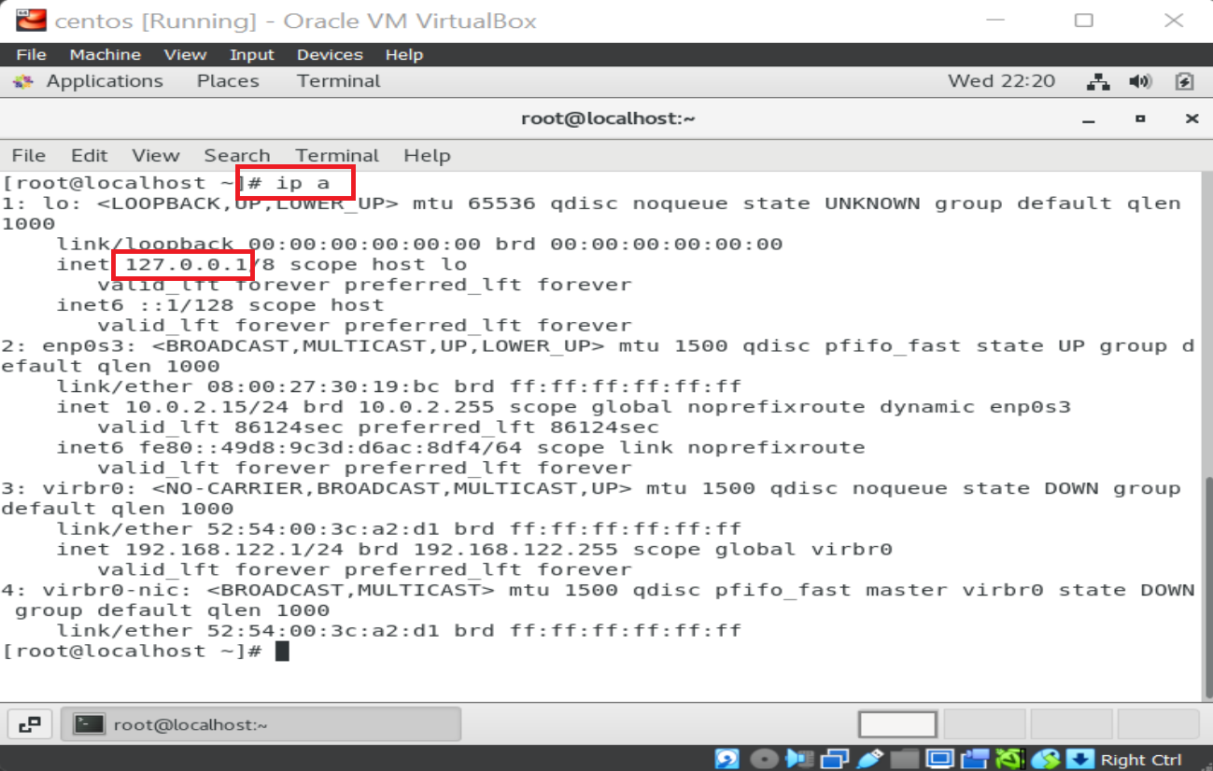

Step 2: go to setting and add adaptor

->select NAT

->Port Forwarding

->add port forwarding rules as below

Name-ssh host ip-127.0.0.1 host port-2222 guest port-22

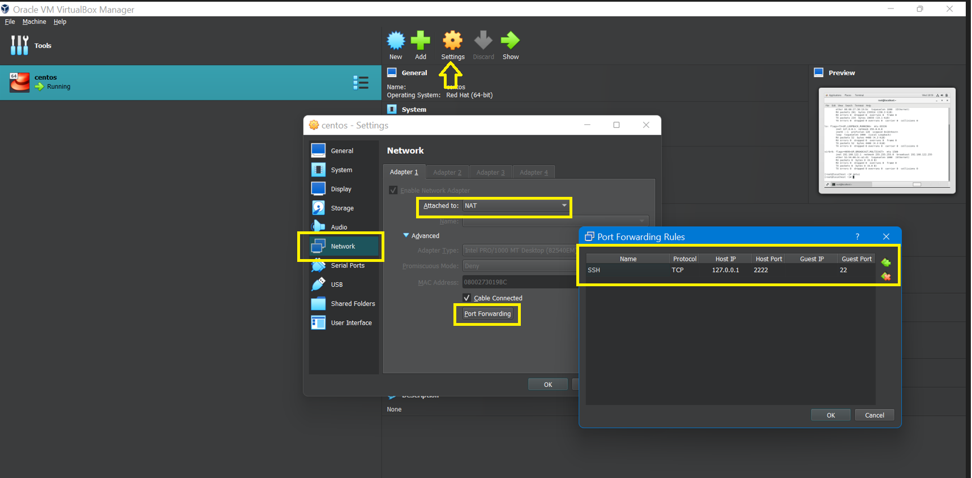

Step 3: Log in to Mobaxterm start new session

Add remote host ip- 127.0.0.1 username-root port-2222

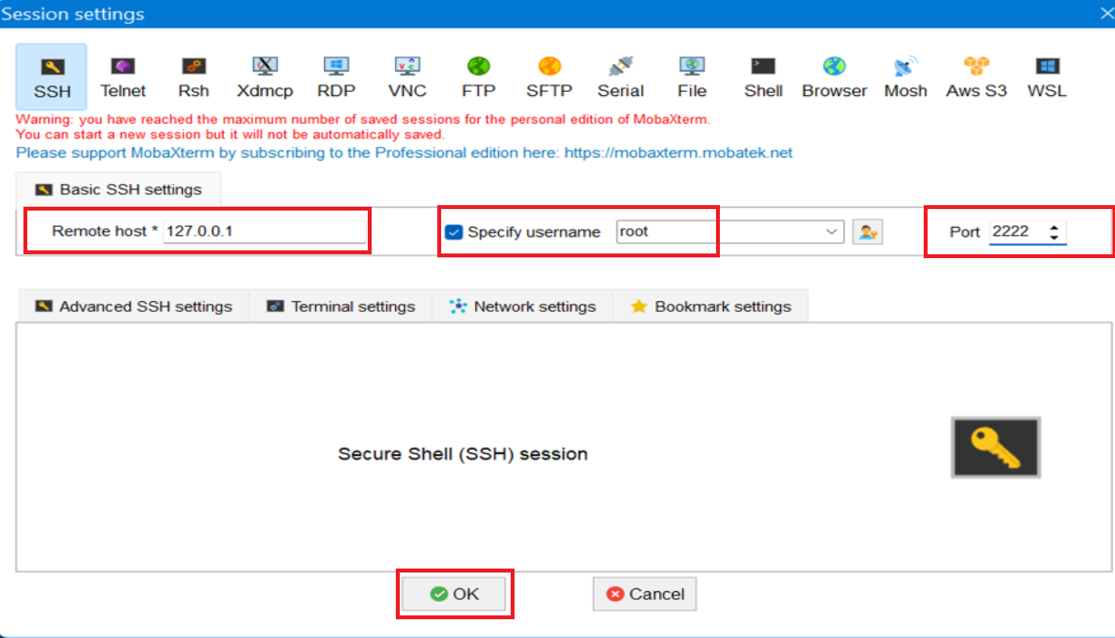

Step 4: Enter Password

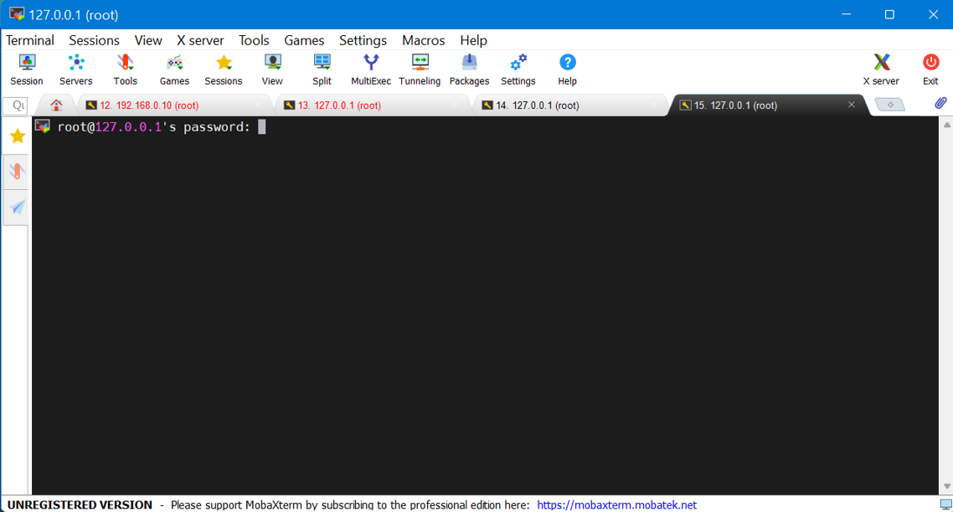

Step 5: Here we go, you have succesfully login into vm

